UDP Client / Server

Ensure you have fully completed all the other tutorials. UDP is best used for data where reliability isn’t required. For example, the server sending a list of connected clients to all clients as this data will be sent out periodically.
As a note – You may wish to prefix the name of all your TCP connection methods and properties with “TCP”. For example; TCPsocket. To help with this use Visual Studios rename feature (ctrl + r, ctrl + r)
Any headers that don’t refer to any of your methods indicates you need to create that method.

Packet
- Create a new packet type called “Login Packet”
- It should store an EndPoint property
  - https://docs.microsoft.com/en-us/dotnet/api/system.net.endpoint?view=netframework-4.8

Server - Client
- Create a new socket and call it UDP socket

Client()
- Instantiate your new socket
  - _UDPsocket = new Socket(AddressFamily.InterNetwork, SocketType.Dgram, ProtocolType.Udp);

Void UDPConnect(EndPoint clientConnection)
- Call Socket.Connect on your UDP socket and pass in the endpoint
  - https://docs.microsoft.com/en-us/dotnet/api/system.net.sockets.socket.connect?view=netframework-4.8
- Send a login packet to your Simple Client using TCP and passing in the LocalEndPoint from your UDP socket.
  - https://docs.microsoft.com/en-us/dotnet/api/system.net.sockets.socket.localendpoint?view=netframework-4.8#System_Net_Sockets_Socket_LocalEndPoint

void UDPSend(Packet packet)
- Serialise your data in the same way as you have done for TCP and then call Socket.Send on your UDP socket and pass in the byte[]
  - https://docs.microsoft.com/en-us/dotnet/api/system.net.sockets.socket.send?view=netframework-4.8#System_Net_Sockets_Socket_Send_System_Byte___

Read
- You can move your read methods to your client and simply call them in your client method on your server
  - 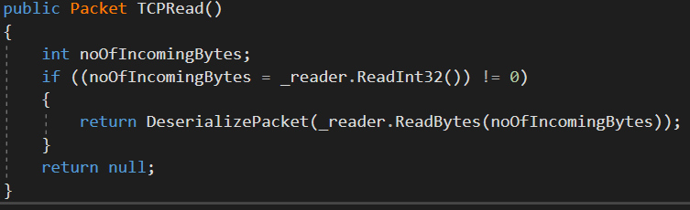
  - 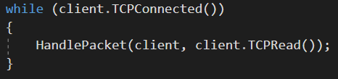
- To read on your UDPsocket
  - byte[] bytes = new byte[256];
  - if ((noOfIncomingBytes = _UDPsocket.Receive(bytes)) != 0)

Server – SimpleServer

Void UDPClientMethod(object clientObj)
- This does everything your TCPClientMethod does except it should read from the UDP socket

HandlePacket()
- When you receive a LoginPacket
  - Call Client.UDPConnect
  - Start a new thread that runs UDPClientMethod()

SimpleClient
- Add a UdpClient property and call it UDPClient
  - https://docs.microsoft.com/en-us/dotnet/api/system.net.sockets.udpclient?view=netframework-4.8

Connect()
- Instantiate your UdpClient
- Call UdpClient.Connect() and pass in your servers IPAddress and Port Number
  - https://docs.microsoft.com/en-us/dotnet/api/system.net.sockets.udpclient.connect?view=netframework-4.8#System_Net_Sockets_UdpClient_Connect_System_Net_IPAddress_System_Int32_
- Send a Login Packet using TCP and pass in the LocalEndPoint from the UdpClient.Client
  - https://docs.microsoft.com/en-us/dotnet/api/system.net.sockets.udpclient.client?view=netframework-4.8#System_Net_Sockets_UdpClient_Client

Send and Receive
- Create send and receive methods like how you did on your server
- To Send
  - UdpClient.Send(byte[] dgram, int byte)
    - https://docs.microsoft.com/en-us/dotnet/api/system.net.sockets.udpclient.send?view=netframework-4.8#System_Net_Sockets_UdpClient_Send_System_Byte___System_Int32_
- To Read
  - Create a new IPEndPoint
  - UdpClient.Receive(ref IPEndPoint) (note – ref passes in the property via reference and will update the property from within the method)
    - https://docs.microsoft.com/en-us/dotnet/api/system.net.sockets.udpclient.receive?view=netframework-4.8

HandlePacket()
- When your client receives a Login Packet call Connect again on your UdpClient and pass in the EndPoint
- Start a new thread for your UDPServerResponse()

Sending UDP Messages
- Create new logic to send UDP packet types

